Demetrios Kechris ME570 HW1 Report

I am using 2 late homework credits for this assignment

* 1. 2 Polygons, one filled and one hollow

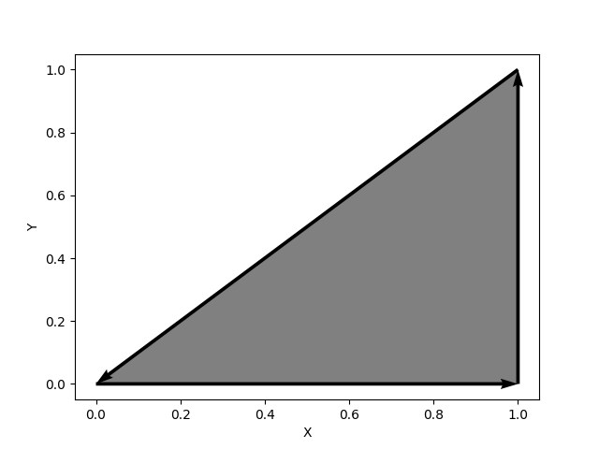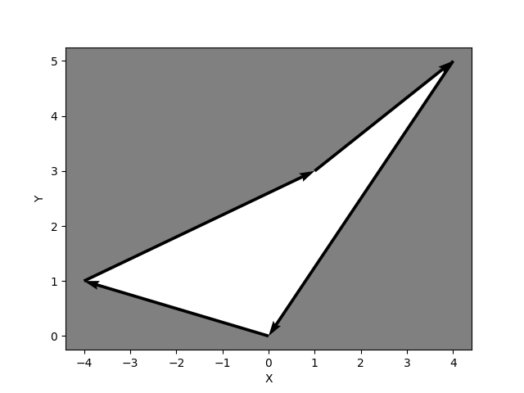

* 1. Call the provided function edge_is_collision_test() five times

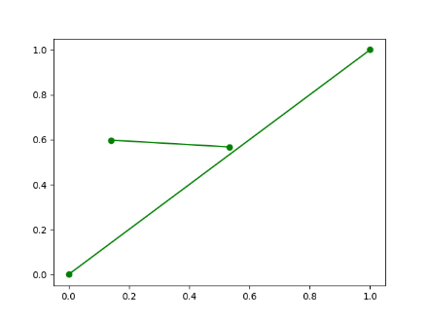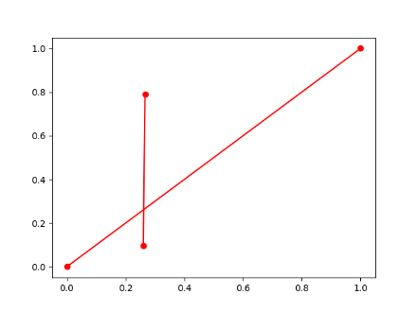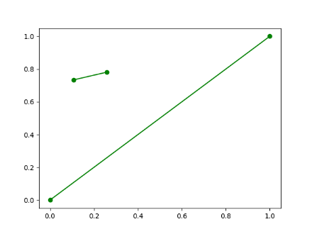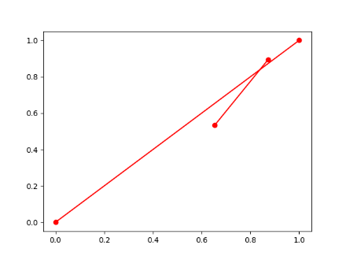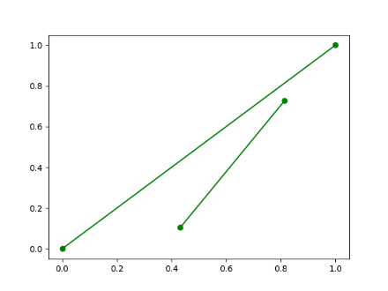

* 1. c_angle is the value of cos(theta) and s_angle is the value of sin(theta). Taking the arctangent of the sine and cosine values gives us the lengths of the vectors, which we can use to get the angle between the two vectors in radians
  2. Run the provided function polygon_is_self_occluded_test() five times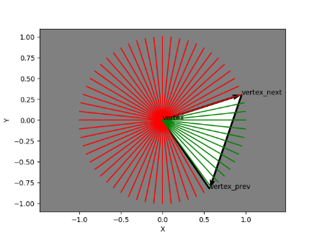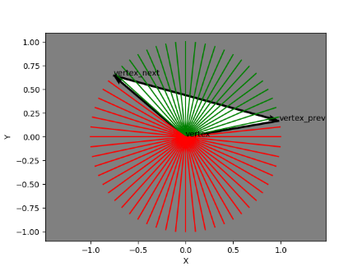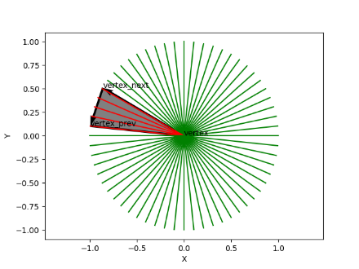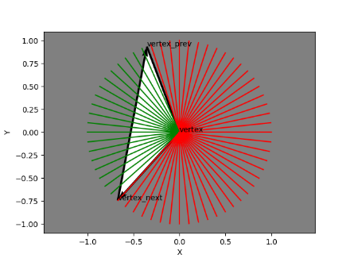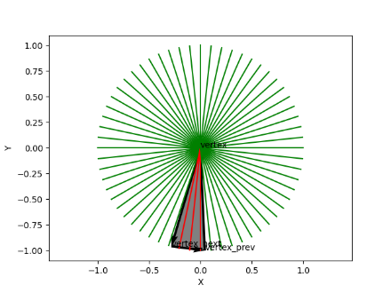
  3. Display four separate figures in total, each one with a single polygon and lines from each vertex in the polygon, to each point.  
     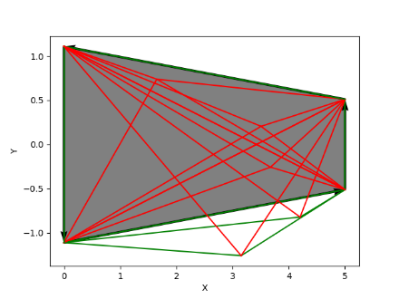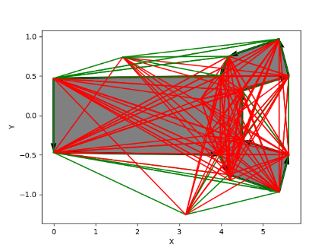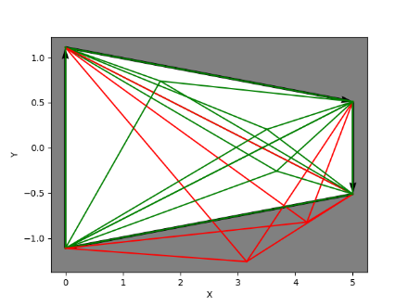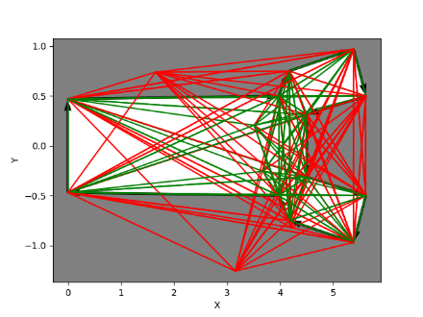
  4. Run the function polygon_is_collision_test()  
     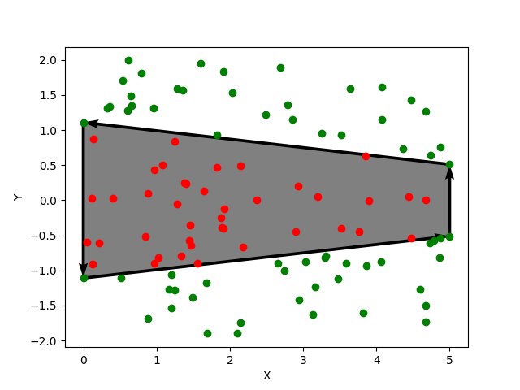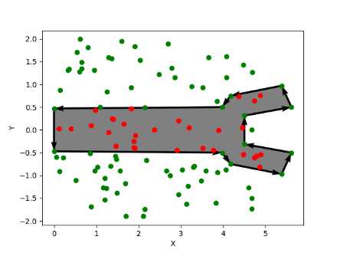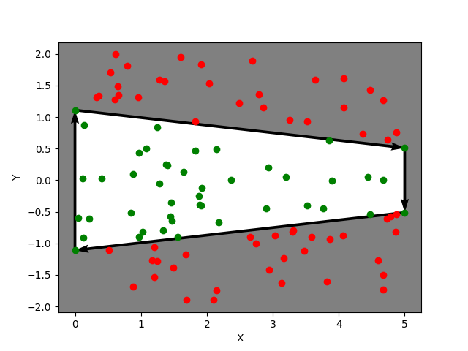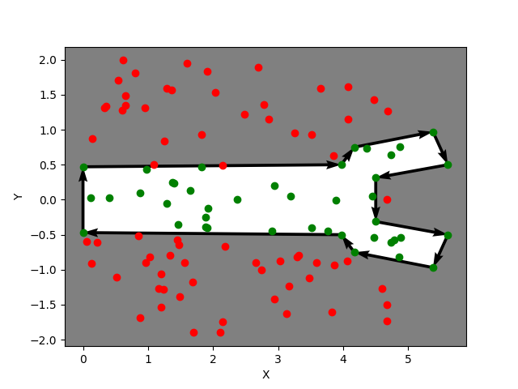

2.1) Run priority_test() and include a copy of the outputs from the command window into your report.

# 1

# 2

('Oranges', 4.5)

('Apples', 1)

('Bananas', 2.7)

# 3

('Apples', 1)

('Oranges', 4.5)

('Bananas', 2.7)

# 4

('Oranges', 4.5)

('Bananas', 2.7)

('Cantaloupe', 3)

# 5

False

True

False

('Oranges', 4.5)

('Bananas', 2.7)

('Cantaloupe', 3)

# 6

('Bananas', 2.7)

('Cantaloupe', 3)

('Oranges', 4.5)

(None, None)

2.2) It depends a bit how we want our end data to look, but if we want a list of coordinates in descending order, we can use priority_queue as follows

P_queueX = ((x, y), cost) where key (x, y) is the coordinate and cost is the associated cost

From here, we can loop min_extract() to get the lowest cost coordinates in an ordered list

To have a list descending by cost, we can either take the min_extract() loop in order and reverse it, or insert the new values at the front of a list

3.1)

T

x(t)T  x (t) =

= $\cos\left(t^{2}\right)*2t\sin{{(t}^{2})}+\sin\left(t^{2}\right)*\left(-2t\right)cos⁡(t^{2})$

= $2t\sin{{(t}^{2})}cos\left(t^{2}\right)-2t\sin\left(t^{2}\right)\cos\left(t^{2}\right)$

= 0

Since the dot product of these two matrices is 0, they will always be perpendicular with each other